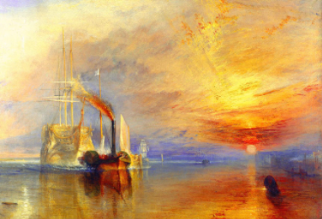
KS2 HALF TERM COMPETITION PROJECT
LO: Use a painting as inspiration for your own artwork
WATCH: In this video, I’m going to tell you a little bit about the painting. Look on the Nine Acres Website under ‘lockdown Learning’ under Whole School Resources.
TASK: For your half term work, we are asking you to respond to the painting ‘The Fighting Temeraire’ by JMW Turner painted in 1839.
Using this painting, you are going to create your own art-work. This can be anything, a photograph, a painting, a play or a piece of writing. On the next page, I have included some ideas you might want to look at for inspiration. Your response might be in the form of:
Singing/dancing (perhaps a Sea Shanty)
Creating a navel costume
Use of ICT to draw/paint
Large scale/small scale artwork
Model making.
Photographs of our local shipping area (The Solent)
Painting/drawing/textiles/collage/printing.
Illustrated writing
Perform your own play script
Fact-file of the painting’s history

You can also use one of your own ideas, this is your chance to be imaginative!
PLEASE SEND PHOTOGRAPHS/VIDEOS OF YOUR WORK TO office@nineacrespri.iow.sch.uk BY WEDNESDAY 24th FEBRUARY TO ENTER THE COMPETITION.
Key vocabulary: Temeraire, Trafalgar, battle, Nelson, sunset, scumbling, impasto, sea, JWM Turner, painting, National Gallery.

About the painting
Full title: 'The Fighting Temeraire tugged to her last berth to be broken up', 1839. Turner’s painting pays tribute to the Temeraire’s heroic past. The gunship, painted delicately in light tones, seems to float effortlessly on calm waters, giving it a ghostly appearance. The glorious sunset behind is a fanfare in her honour.
Just as the day is drawing to a close, so too is the life of the Temeraire. The nostalgic and melancholic mood of the painting is emphasised by the fact that the ship can no longer travel by the power of her own sails; they have been furled for the last time and a steamboat tugs her into the shore. Turner paints the two boats in sharp contrast to each other – the steam boat moves ahead of the grand gunship: squat, dirty and ugly in comparison.
The Fighting Temeraire by Turner was chosen above names such as Van Gogh, Hogarth and Hockney to be named the greatest painting in Britain in a public vote in 2005, organised by BBC Radio 4's Today programme in association with the National Gallery, London.
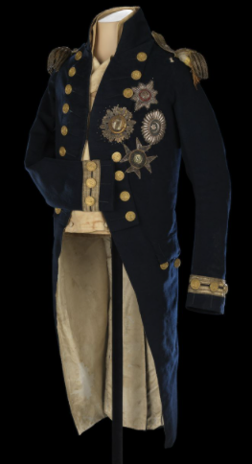
Below are some visual suggestions for your response:
