Year 5 science – Week 6 Mechanisms
LO: To recognise that some mechanisms including levers, pulleys and gears allow a smaller force to have a greater effect.
Success Criteria: | Pupil | Teacher
I can sort levers, gears and pulleys
I can describe how different mechanisms affect the force

Remember – What is a force?  We can't see forces, but they are an important part of our everyday lives. Forces are acting on us all the time! Forces affect us when we drive to school or fly on holiday. Because human beings have a good knowledge of forces, we can build houses that don’t fall down and chairs that don’t collapse. It enables us to launch satellites into orbit that can beam television signals around the world and map the planet from space! Simple forces are pushes and pulls | Key Question – What is a mechanism?
 | Word Bank - Air resistance, Water resistance, Friction, Gravity, Newton, Gears, Pulleys, force, push, pull, opposing, streamline, brake, mechanism, lever, cog, machine, pulley, move, speed, slow, fast, spin, turn
Mechanisms A mechanism is a device which takes an input motion or force, and outputs a different motion and force. The point of a mechanism is to make the job easier to do, they do this by allowing a smaller force to have a greater effect. There are different types of mechanisms. The mechanisms most commonly used in mechanical systems are levers, linkages, cams, gears, and pulleys.Today, we will be looking at gears, pulleys and levers.
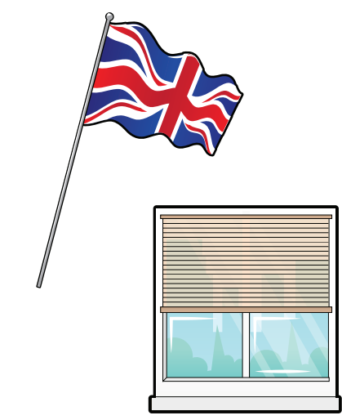
Pulleys A pulley is a wheel with a grooved rim around which a cord passes. The pulley acts to change the direction of a force applied to the cord and is used to raise heavy weights. Pulleys are used to help you use a small force to lift a large load. An example of this in everyday life is a window blind. We pull the string with little force which then pulls the blind up. Another example is a flag. Again, we pull the rope with some force which pulls the flag up the flagpole.

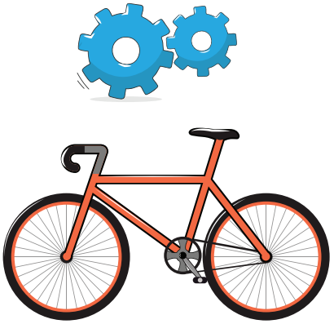
Gears Gears can be used to change the speed, force or direction of motion. Gears are wheels with teeth, or indentations, which lock together and turn one another. Gears are used on bicycles to make it easier to go fast or climb a steep hill. If you turn a bicycle upside down you can see how the large gear wheel attached to the pedals drives a small gear wheel on the back wheel by means of the chain. You can select a gear for climbing a hill which makes you pedal very quickly. Alternatively, you can select a gear for going fast with very few turns of the pedal.

Levers Levers are used to help you use a small force to lift a large load. A lever always rests on a pivot. A lever always has three things – the point where you push or pull, the point where it pivots, and the point where the work is done. An example of a lever in everyday life is a see saw. One person pushes up with their legs, sending themselves upwards. They then come down, causing the other person to move upwards. They are using minimum force but they are moving a person!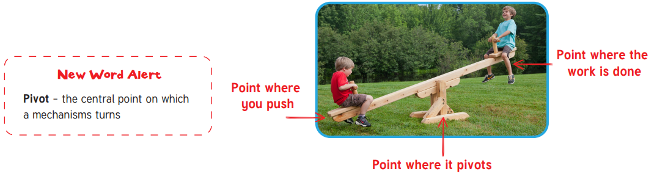
Check
Write whether these statements are true or false. If it is false, correct the statement to make it true.
Statement | True or False | Correction if false
1. Levers and pulleys can be used to make a small force lift a larger load.
2. Pulleys are wheels with teeth which lock together and turn one another.
3. A lever is a wheel or a collection of wheels over which a rope is looped.

Watch some mechanisms in action - https://www.bbc.co.uk/bitesize/clips/zrp6n39 Levers https://www.youtube.com/watch?v=LiBcur1aqcg pulleys
https://youtu.be/qybUFnY7Y8w a video of a Rube-Goldberg machine. It is a very complicated arrangement of moving parts that make up a large machine. See if you can spot examples of levers, pulleys and gears as you watch.

Sort these mechanisms, by drawing and labelling them into the correct boxes below.

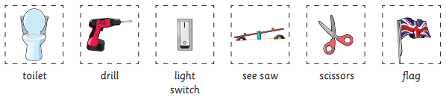
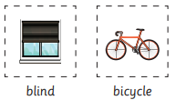
Think of examples of gears, levers and pulleys that you might find around your house or around school. Can you think of another for each box? Draw and label them in the correct boxes above.

Mini Investigation We are now going to carry out a mini investigation based on levers. You will need a pencil, ruler and rubber.
1. Put the rubber on one end of the ruler.
2. Use the pencil as a pivot.
3. Put the pivot on the 5cm mark on the ruler and push down to lift the rubber. How easy is it to lift the rubber?
4. Repeat step 3 with the pivot at 10cm, 15cm, 20cm, and 25cm.
5. Consider at which point was it easiest to lift the rubber and at which point was it hardest.
How does changing the position of the pivot affect the amount of force required to lift the weight?
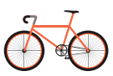
Challenge - Explain why gears are useful to have on a bicycle. Use scientific vocabulary from your word bank.

What I know now that I didn’t know before.

