Tuesday 2nd March 2021 - Answers

**Early Bird**

**Mrs Smith’s Group**

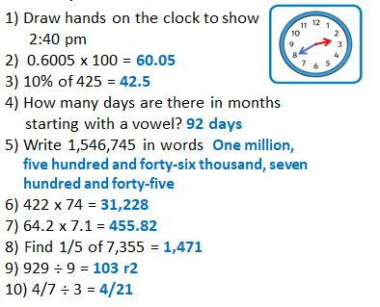

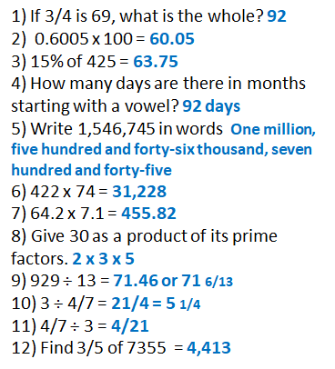

**On this day:**

1. Write the year it was released in Roman Numerals. **MCMLXV**
2. How long ago was this? **56 years**

**Maths**

|  |
| --- |
| Date: 2.03.2021 Title: Number - Decimals      LO: Applying decimal division to a variety of problems |
| **Key Question:** |
| **Fluency: G I** 1) 340 2) £3.33 3) 44km 4) £330.66  5) A - £1.92 B- £1.93 so A is better 6) £7.55 ÷ 5 = £1.51 so the  chocolate bar costs £1.51 and the box costs £6.04. The difference is £4.53 |
| **Problem Solving:**  **G I** |
| **Reasoning: G I** |
| **Testbase: G I** |
| **Support fluency: G I** |
| **More Practice: G I**   1. **2.3 b) 1.3 c) 3.2 d) 2.1 e) 2.4 f) 1.7 g) 3.7**   **h) 1.2 i) 2.4 j) 3.1 k) 1.3 l) 7.3** |
|  |
|  |

|  |
| --- |
| **Spelling:** |