Year 4 science - Week 6 Gases
LO: To research the work of scientist Joseph Priestly.
Success Criteria: | Pupil | Teacher
I can recall facts about Joseph Priestly

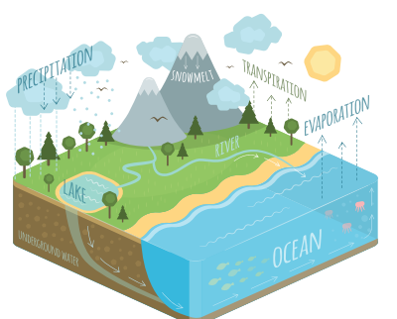  Remember - The water cycle song - https://www.youtube.com/watch?v=qGmFpVL15QA | Key Question - How many gases can you name in 1 minute?
Word Bank - Solid, liquid, gas, particles, state, materials, properties, matter, temperature, process, energy, heat, carbon dioxide, oxygen, curiosity,
Today we are going to be researching Joseph Priestly and his important discoveries. Watch this clip - https://www.bbc.co.uk/bitesize/clips/zkcb4wx and make notes of all the interesting information you can find out about him and his discoveries. Please look at other sources (online or in books) to add to your notes.

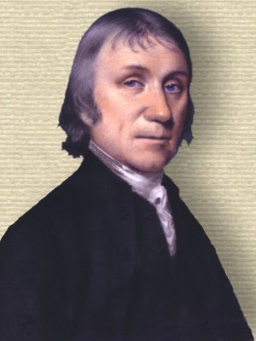

Joseph Priestly

Challenge - Write whether these statements are true or false. If it is false, correct the statement to make it true.
Statement | True or False | Correction if false
Priestley discovered oxygen gas.
Priestley gave his discovery, carbon dioxide, its name.
Priestly invented fizzy drinks.

What I know now that I didn’t know before.

