**Answers –Wednesday 13th January 2021**

**Early Bird Maths**

**Early Bird (Mrs Smith’s Group)**

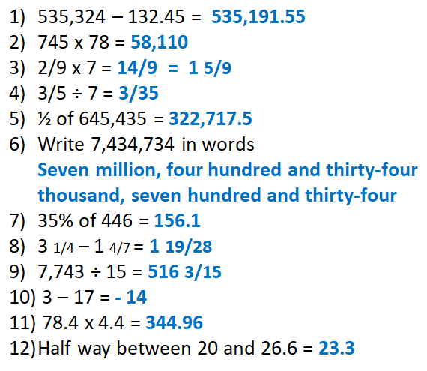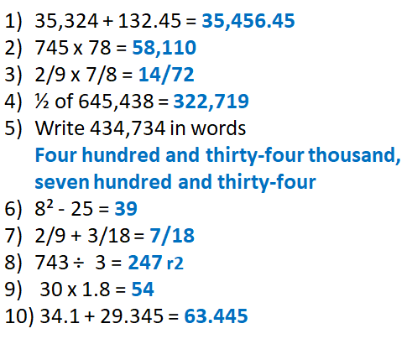

**On This Day**

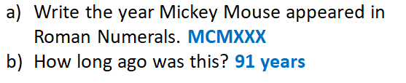

|  |
| --- |
| Key Question: |
| Fluency: |
| Reasoning: Is Amir Correct?  **No he is not correct** |
| Problem Solving: |
| Testbase: |

|  |
| --- |
| More Practice: |
|  |
|  |

|  |
| --- |
| Spelling: |