WEEK 2
EARLY BIRD MATHS 1
MUST:
21 + 7 + 7 =
207 – 1 =
3 X 11 =
46 X 0 =
496 + 351 =
65 ÷ 1 =
2209 – 10 =
2/7 + 4/7 =
72 ÷ 6 =
893 – 238 =
98 ÷ 7 =

SHOULD:
34,175 + 2907 =
82.2 + 5.6 =
2 x 5 x 3 =
40.01 x 10 =
Remember: Equivalent fractions
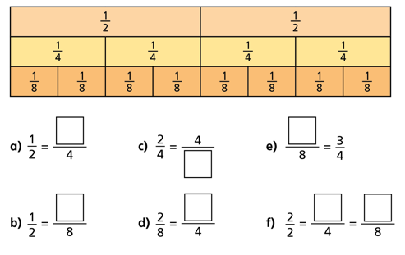
55,906 – 5821 =
1732 x 9 =
40 x 40 =
2³ + 4² =
3.4 ÷ 1000 =
39.1 – 6.09 =

COULD:
¾ of 36 =
1/6 of 504 =
4.206 x 8 =
2738 x 36 =

CHALLENGE:
0.23 = ?% (What does percent mean?)
3 1/5 x 2 = (turn the fraction into a decimal)
0.12 = ?/100 (look at the place value columns)
5/6 - 1/3 = (denominators have to be the same)

EARLY BIRD MATHS 2
MUST:
75 x 1 =
27 + 9 + 9 =
54 ÷ 5 =
905 x 0 =
5480 – 100 =
409 + 87 =
9/11 – 3/11 =
6 x 6 =
980 + 50 =
725 – 88 =
1459 + 1447 =
9.4 – 5.8 =

SHOULD:
5² =
5 x 4 x 2 =
24.1 x 1.0 =
92 ÷ 8 =
10,981 – 448=
2074 x 4 =
400 x 40 =
3.7 ÷ 100 =
5.3 + 1.95 =

COULD:
1/7 of 77 =
5.17 x 9 =
529 x 43 =
5/8 of 160 =

CHALLENGE:
0.9 = ?% (What does percent mean?)
0.4 = ?/100 (look at the place value columns)
1/4 + 1/8 = (denominators have to be the same)
3/8 x 5 = (Think of this as 5 lots of 3/8 …see below)
Tip:
Think of x as ‘lots of’
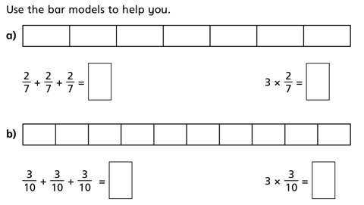

EARLY BIRD MATHS 3

MUST:
87 x 0 =
24 + 4 + 4 =
6050 – 1000 =
394 + 8 =
805 ÷ 1 =
873 + 19 =
4 x 12 =
72 ÷ 6 =
2639 + 4998 =
824 – 268 =
5/9 + 5/9 =
8.6 + 5.6 =

SHOULD:
2 x 5 x 3 =
962 ÷ 5 =
21,125 – 9608 =
75.3 ÷ 10
Remember:
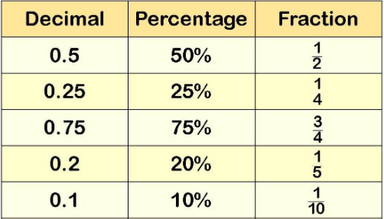
36.21 x 100 =
50 x 40 =
1083 x 7 =
3³ + 5² =
76.4 – 1.95 =

COULD:
6/7 of 63 =
¼ of 308 =
93 x 28 =
261.8 x 4 =

CHALLENGE:
0.15 = ?% (What does percent mean?)
3 1/4 x 3 = (turn the fraction into a decimal)
0.6 = ?/10 (look at the place value columns)
5/6 – 1/12 = (denominators have to be the same)

EARLY BIRD MATHS 4

MUST:
42 x 1 =
4/5 – 1/5 =
36 + 6 + 6 =
450 + 200 =
123 x 0 =
8 x 4 =
927 + 59 =
872 – 84 =
3901 + 100 =
48 ÷ 4 =
3097 + 3605 =
7.5 – 1.9 =

SHOULD:
5 x 4 x 2 =
3² =
Tip:
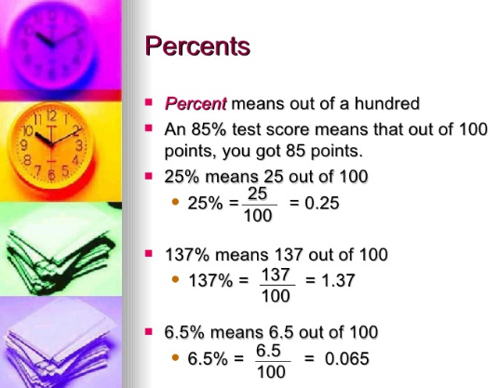
86 ÷ 3 =
0.68 ÷ 10 =
2074 x 8 =
34001 – 15806 =
300 x 60 =
5.8 x 1000 =
6.9 + 6.15 =

COULD:
1/6 of 96 =
2.814 x 5 =
3/8 of 120 =
607 x 38 =

CHALLENGE:
0.2 = ?% (What does percent mean?)
5/8 x 2 = (swap it around and think of ‘x’ as ‘lots of’)
0.38 = ?/100 (look at the place value columns)
1/10 + 5/10 = (denominators have to be the same)

EARLY BIRD MATHS 5

MUST:
98 x 0 =
5 x 8 =
35 + 7 + 7 =
3344 – 10 =
79 ÷ 1 =
274 + 907 =
33 ÷ 11 =
4/9 + 1/9 =
452 – 80 =
67 x 3 =
3498 + 901 =
672 – 333 =

SHOULD:
96 ÷ 6 =
Tip:
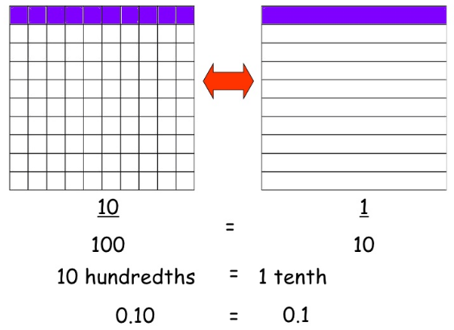
36.9 + 5.8 =
3 x 5 x 3 =
10,555 – 7,678 =
70 x 40 =
0.6 x 100 =
1³ + 6² =
146.1 ÷ 1000 =
31.8 – 6.45 =

COULD:
1/7 of 294 =
7.14 x 6 =
5/6 of 120 =
1357 x 26 =

CHALLENGE:
0.05 = ?%
0.9 = ?/100
9/10 – 1/5 =
1/7 x 4 =

