Lesson 5: Multiply 2-digits (area model) EXTRA CHALLENGES
ONLINE VIDEO SUPPORT: www.whiterosemaths.com/homelearning/

Go to Year 5 🡪 Week 1 Number: multiplication division
USE THE ARRAY METHOD TO COMPLETE THESE CHALLENGES.  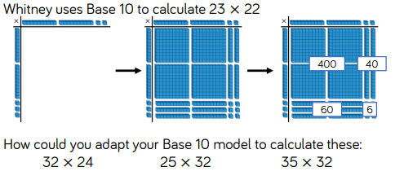  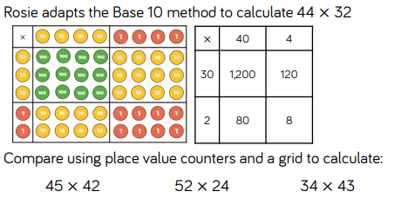  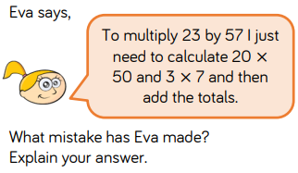 | 