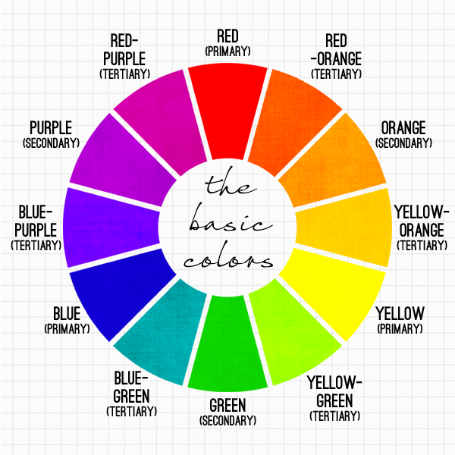

**Art Lesson 3**

LO: Develop understanding of complementary colours

Useful Website: https://artclasscurator.com/color-in-art-examples/

TASK: Watch the video for ‘Art Lesson 3’ on the Nine Acres website (https://www.nineacrespri.iow.sch.uk/website/year_four/530932).

**Step 1:**  Using the colour wheel, decide which two complementary colours you would like to use (yellow and purple, green and red, blue and orange). Collect objects around the house that match one of your chosen colours, in as many tones as possible.

**Step 2:** Arrange your objects so that they form a ‘still life’ (think ‘triangle’ shape!).

**Step 3:** Using light pencil stokes, roughly block in your still life using geometric shapes.

**Step 4**: Using paints, oil pastels or layered colouring pencils, use your colour mixing skills to paint each object, thinking about the different tones and textures of the objects

**Step 5:** To achieve a darker tone, the complementary colour can be used eg, mix some orange into your blue to get a darker blue for the shadows.

**Step 6** – Background – use your complementary colour to render your background. This will make your still life really shine!

**Key vocabulary: geometric shape, complimentary opposite, primary, secondary, tertiary, tone, texture, render**

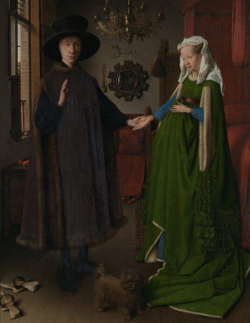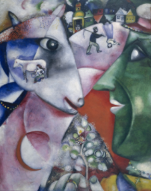**Examples of artists who use complementary colours**

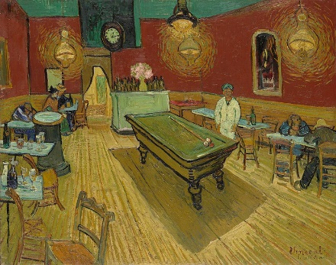**Green and red:**

Marc Chagall, [*I and the Village*](http://www.moma.org/collection/object.php?object_id=78984), 1911

Vincent van Gogh, [*The Night Café*](https://en.wikipedia.org/wiki/Complementary_colors#/media/File:Vincent_Willem_van_Gogh_076.jpg), 1888

Jan van Eyck, [*The Arnolfini Portrait*](http://www.nationalgallery.org.uk/paintings/jan-van-eyck-the-arnolfini-portrait), 1434

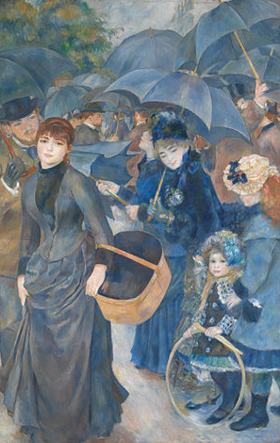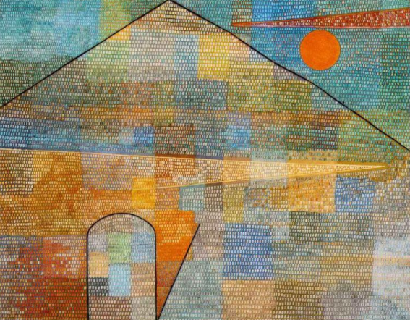**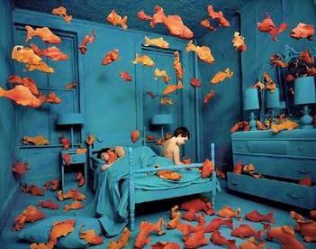Orange and blue:**

Sandy Skoglund, [*Revenge of the Goldfish*](https://en.wikipedia.org/wiki/Revenge_of_the_Goldfish_%28photograph%29), 1981

Pierre-Auguste Renoir, The Umbrellas, 1880

Paul Klee, [*Ad Parnassum*](http://www.wikiart.org/en/paul-klee/to-the-parnassus-1932), 1932

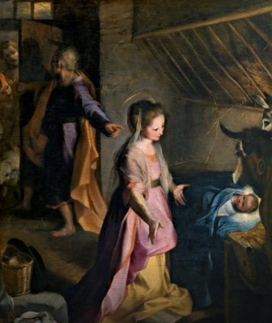**Purple and Yellow:**

Federico Barocci, [*The Nativity*](https://www.museodelprado.es/en/the-collection/online-gallery/on-line-gallery/obra/the-birth/?no_cache=1), c. 1597

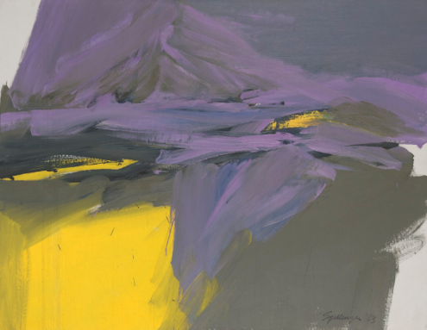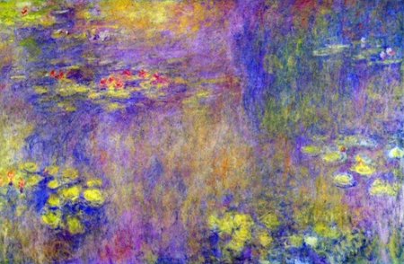

Ray Spillenger, [*Purple and Yellow*](http://www.walkerart.org/collections/artworks/purple-and-yellow), 1963

Claude Monet, [*Water Lilies*](http://www.wikiart.org/en/claude-monet/water-lilies-1919-9#supersized-artistPaintings-212922), 1914-1926