**Answers – Thursday 14th January 2021**

**Early Bird (Mrs Smith’s Group)**

**Early Bird Maths**

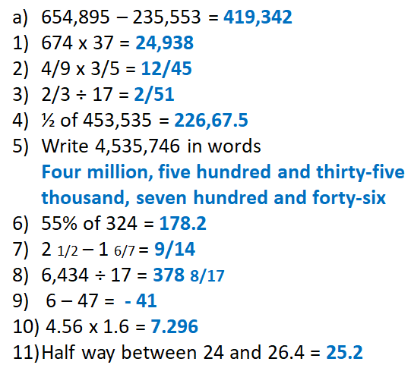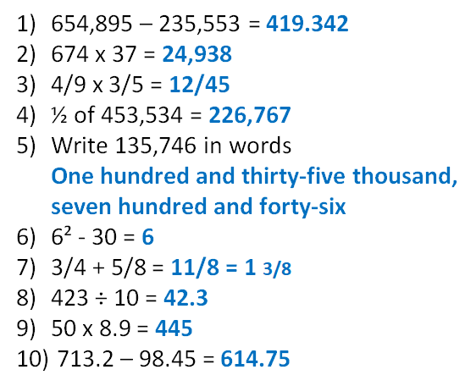

**On This Day**

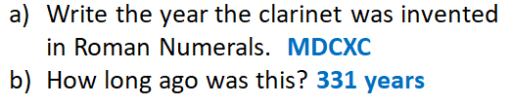

|  |  |
| --- | --- |
| Key Question: | |
| Fluency: | |
| Reasoning: | |
| Problem Solving: | |
| Testbase: | |
| More Practice: | |
|  |  |

|  |
| --- |
| Spelling: |