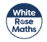
EYFS Yearly Overview for Maths
We follow the White Rose Maths programme however this is adapted to meet the needs of our pupils and their starting points. We supplement our Mathematics Teaching with resources from a range of other sources, such as NRICH and NCETM, for extra challenge and investigations.
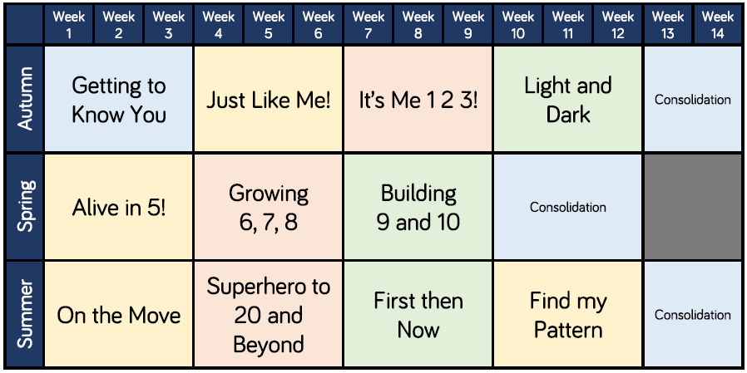
This overview is subject to a recovery curriculum and is adapted in light of pupils’ assessments and teacher judgements.

