**Answers –Tuesday 12th January 2021**

**Early Bird (Mrs Smith’s Group)**

**Early Bird Maths**

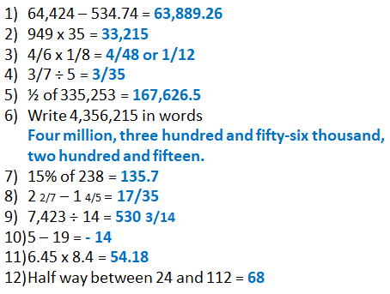

**On This Day**

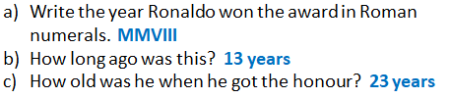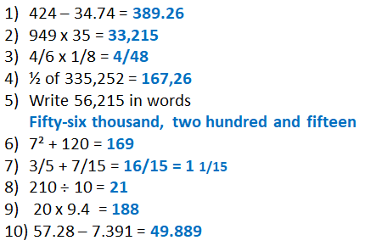

|  |
| --- |
| Key Question: |
| Fluency: |
| https://lh4.googleusercontent.com/QAQ3wdqIEplhgY99K7FknG-Hwf3shJCDddeCb8WedLG_VrvuNM2G0aKy2VilIz3mMlmCHOCRRri_IeSJ1vyI8gFP-mmmgQ7uD02EVamQ9vUO7bhTzPxcUdWghHJqzkei67OFMmUReasoning: **Tommy is incorrect.**  **40/60, 20/30 and 10/15 are all equivalent fractions.**  **10/15 is not the simplest form, as both 10 and 15 can be divided by**  **5 to get 2/3** |
| Problem Solving: |
| Testbase: |

|  |  |
| --- | --- |
| More Practice: | |
|  |  |

|  |
| --- |
| Spelling: |