Friday 5th March 2021 - Answers

**Early Bird**

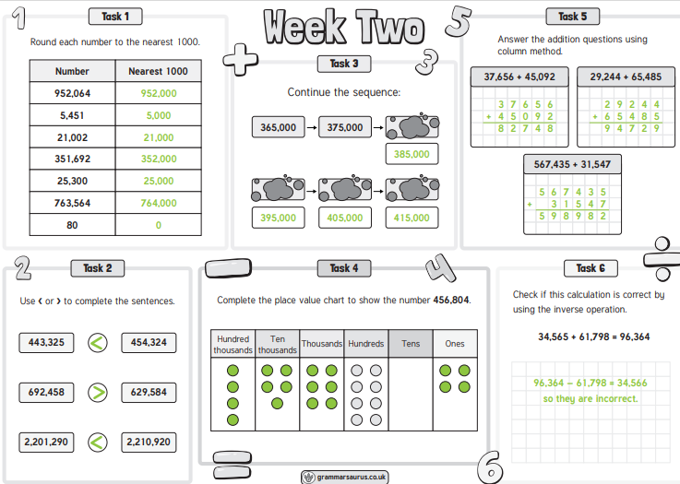

**On this day:**

1. Write the year that he was born in Roman numerals. **MCXXXIII**
2. How long ago was this? **888 years**

**Maths**

|  |
| --- |
| Arithmetic |

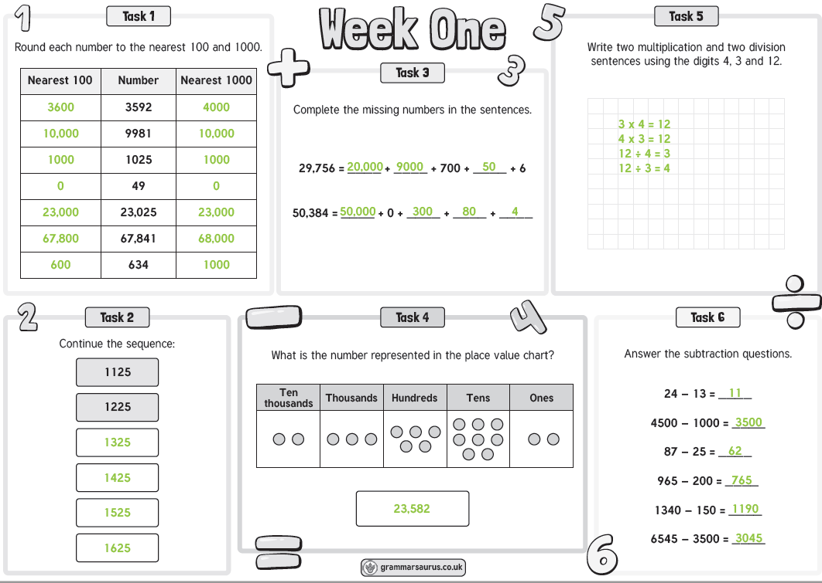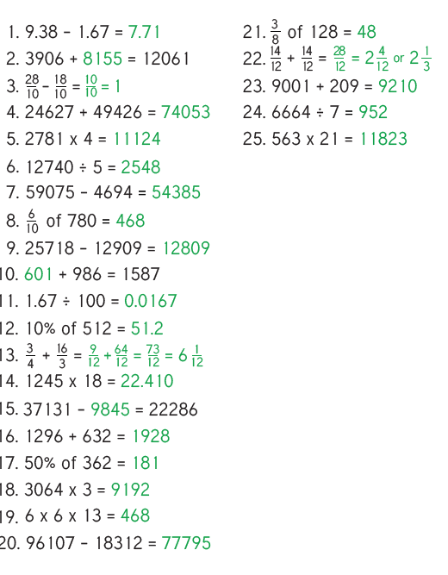

|  |
| --- |
| **Spelling:** |