Monday 1st March 2021 - Answers

**Early Bird**

**Mrs Smith’s Group**

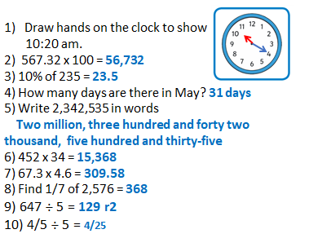

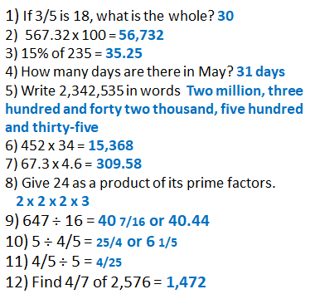

**On this day:**

1. Write the year he was created in Roman Numerals. **MCMXLI**
2. How long ago was this? **80 years**

**Maths**

|  |
| --- |
| Date: 1.03.2021 Title: Number - Decimals      LO: Dividing a fraction by an integer (whole number)  Link to today’s concept video: https://vimeo.com/490691239 (hyperlinks on the website) |
| **Key Question:**  Start with more practice if you did not get this correct or else move straight to fluency. |
| **Fluency: G I**   1. 0.65 b) 1.45 c) 0.28 d) 4.86 e) 1.35 f) 0.0076 g) 0.175 h) 0.355 |
| **Problem Solving:**  **G I**  Super Saver – 19p each  TopBuys – 21p each  BestBuys – 22p each  Super Saver is the best value. |
| **Reasoning: G I** |
| **Testbase: G I** |
| **Support fluency: G I** |
| **More Practice: G I** |
| **Challenge :**  £4.30 |
|  |

|  |
| --- |
| **Spelling:** |