Thursday 4th March 2021 - Answers

**Early Bird**

**Mrs Smith’s Group**

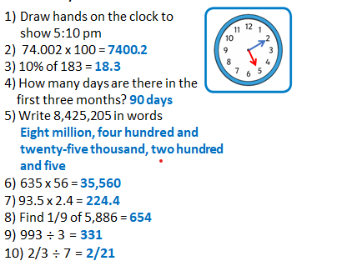

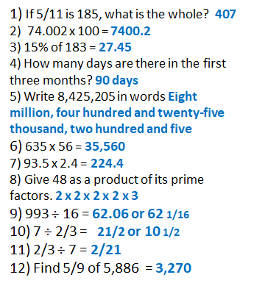

**On this day:**

1. Write the year of the first flight in Roman Numerals. **MCMXXXVI**
2. How long ago was this? **85 years**
3. Does anyone know what happened to her a year later? **In 1937 Hindenburg burst into flames when landing**

**Maths**

|  |
| --- |
| Date: 4.03.2021 Title: Number - Decimals      LO: To convert fractions to decimals lesson1 |
| **Key Question:** |
| **Fluency: G I** |
| **Problem Solving:**  **G I** |
| **Reasoning: G I** |
| **Testbase: G I** |
| **Support fluency: G I** |
| **More Practice: G I** |
| **Challenge :** |
|  |

|  |
| --- |
| **Spelling:** |