Spring Term Lockdown
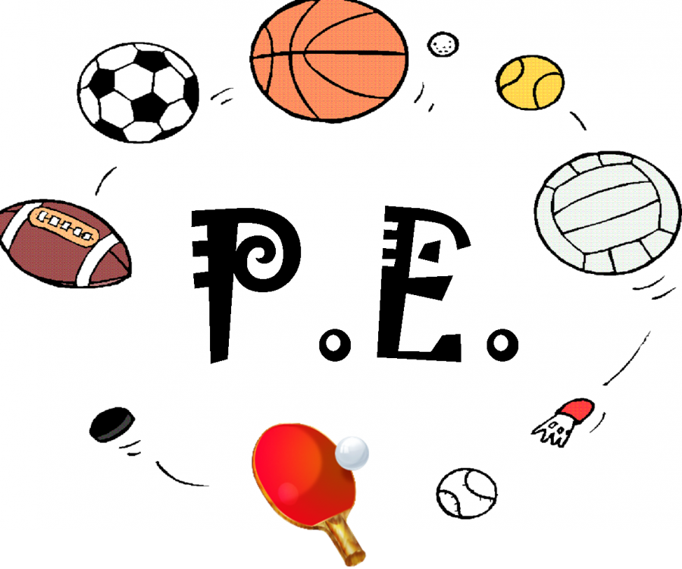

Being physically active and keeping fit can be difficult during lockdown. Here are some fun challenges and activities which can you do at home to help you be active and stay fit.
Please keep checking this page for weekly challenges and new resources.

PE Challenge- KS2 Children
ATTACHED DOCUMENT- Healthy Heart

Healthy Selfie Lockdown Challenge
Can you take a photo of yourself taking part in some form of physical activity and send it in to the office?
Children in Year 5 and 6 it would be great if you can use the following challenge for your healthy selfie, we would love to see your ideas!
ATTACHED DOCUMENT -TTT Active Challenge Active Indoors

Other ideas and recommendations
Joe Wicks is back with his online PE lessons which go live at 9 am Monday, Wednesday and Friday morning on his YouTube Channel ‘The body coach’. These are great medium intensity workouts which last around 15-30 minutes and are good fun to do with all the family.
https://www.youtube.com/user/thebodycoach1

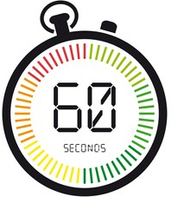
60 Second Challenges
The Youth Sports Trust has put together a range of fun challenges for you to try which only last 60 seconds. We would like you to chose one or two activities a week, practise the activity and see how much you can improve your personal best.
https://www.youthsporttrust.org/60-second-physical-activity-challenges

Cosmic Yoga
Yoga is great for all ages and is another fun way which will help you stay active, build strength and improve balance as well as helping you to relax. To make it even more fun you can choose the theme which can be super heroes, mermaids, Minecraft and lots more!
https://www.youtube.com/user/CosmicKidsYoga

Just Dance Kids YouTube
Lots of dance videos here, dance along to your favourite song or movie!

BBC Super Movers
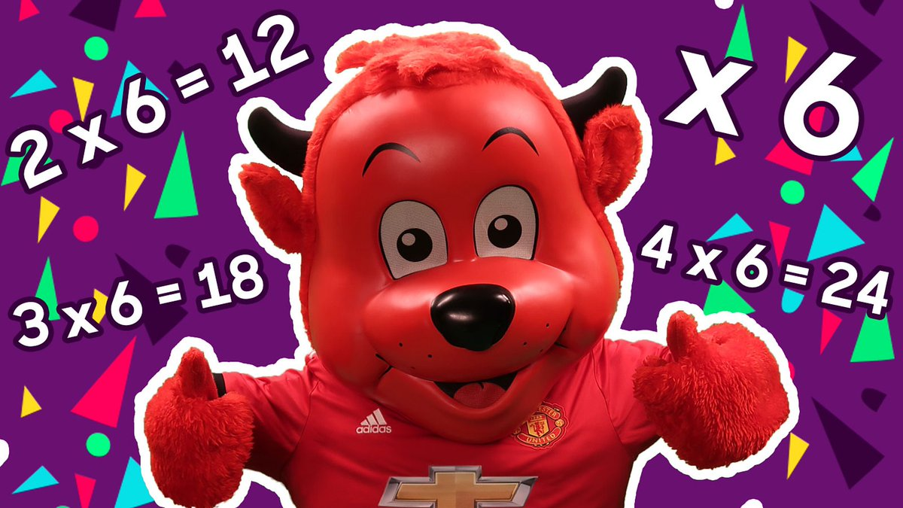
Lots of videos here for children in both key stages. Learn English and maths skills such as times tables, fractions and commonly misspelt words whilst keeping active.
https://www.bbc.co.uk/teach/supermovers

