Wednesday 3rd March 2021 - Answers

**Early Bird**

**Mrs Smith’s Group**

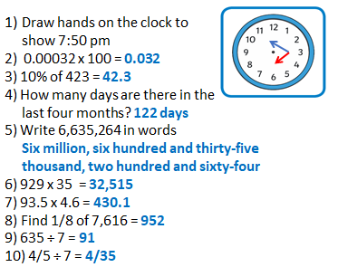

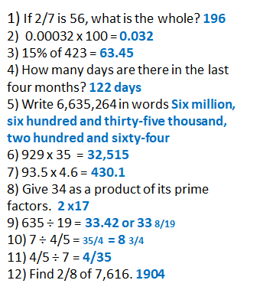

**On this day:**

1. Write the year he was born in Roman Numerals. **MDCCCXLVII**
2. How long ago was this? **74 years**
3. What is he famous for? **He invented the telephone**

**Maths**

|  |
| --- |
| Date: 3.03.2021 Title: Number - Decimals      LO: To explore the relationship between decimals and fractions |
| **Key Question:** |
| **Fluency: G I** |
| **Problem Solving:**  **G I** |
| **Reasoning: G I** |
| **Testbase: G I** |
| **Support fluency: G I** |
| **More Practice: G I** |
| **Challenge :**  Sam – ¼  Mark – 3/10  Jill – 35/100 which is 7/20  As equivalent fractions: Sam 5/20, Mark 6/20, Jill 7/20 so 18/20 were eaten and 2/20 were left. Best answer is 1/10 |
|  |

|  |
| --- |
| **Spelling:** |