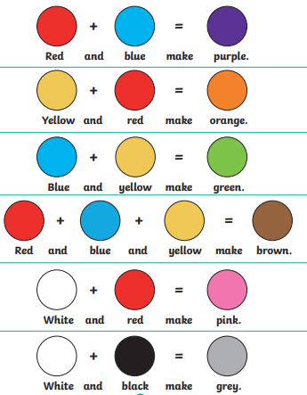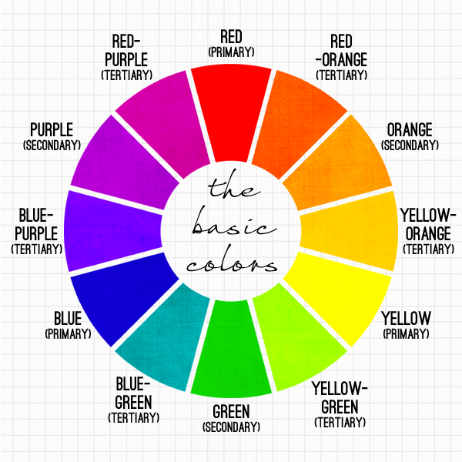
Art Lesson 1
LO: Develop colour mixing skills
TASK: Watch the video for ‘Art Lesson 1’ on the Nine Acres website (https://www.nineacrespri.iow.sch.uk/website/year_four/530932).
Step 1: Select a range of colours form packaging, magazines, and leaflets. Try to choose a range of colours from across the colour wheel. Stick your chosen colours (between 8 – 10) to the right hand side of the page.
Step 2: Using paints (or layered colouring pencils if you don’t have them), make three or four attempts to make the colour you have chosen
Step 3: continue until you have matched all of the colours.
TIPS:
- To make a tone darker you can add its complimentary opposite (green + red, blue + orange, yellow + purple)
- Mix colours slowly, so you can adjust them if necessary.
- Your print out copy of this sheet will not be in colour, but use the video and the labels underneath the colours to help you.
Key vocabulary: light, dark, complimentary opposite, attempt, match, primary, secondary, tertiary

Original colour | Attempt 1 | Attempt 2 | Attempt 3 | Attempt 4 | Evaluate – which attempt was best? What colours did you mix to create it?

