Science poster competition
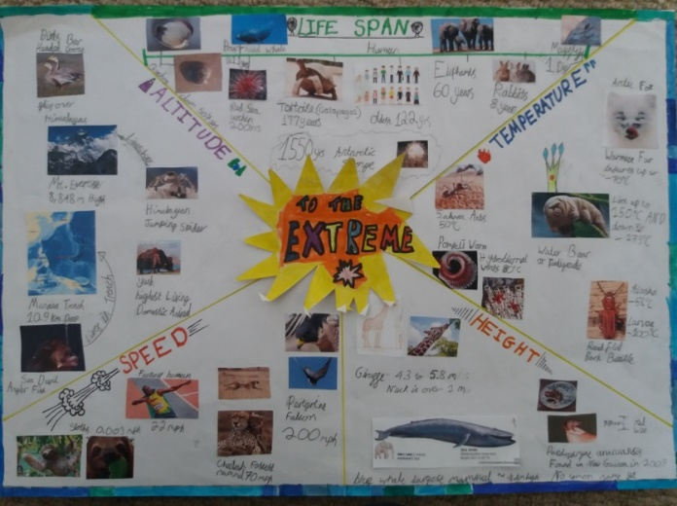
Due 19th February 2021
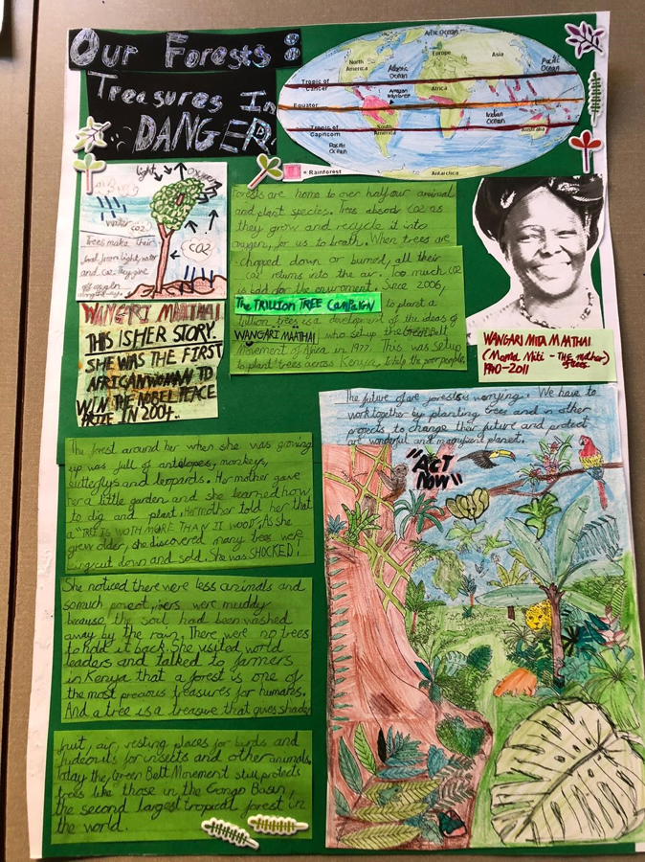
This year the British Science Association is running a poster competition. Nine Acres Primary will select and award prizes to the top 5 posters to then send on to the panel of judges. This is an optional competition with some fantastic prizes up for grabs!
The theme for 2021 is ‘Innovation for the Future.’ See the website below for some more ideas. https://www.sciencefocus.com/future-technology/future-technology-22-ideas-about-to-change-our-world/
See below for key rules and some examples of the winners from last year. Key rules:
- Entries must be one page of A4 or A3 paper only.
- Work must be original and created by the student(s) – Posters are judged on the following criteria:
- Creativity in approach – innovative angle on the content or creative interpretation of the theme
- Content – clear, accurate and informative
- Effective communication – presented and communicated in an engaging way
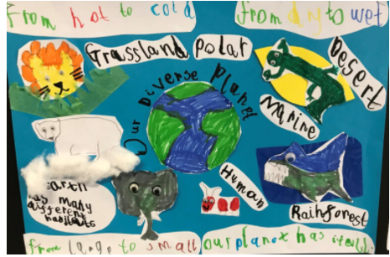

Deadline is the 19th February – Please drop these into school and leave at the office. Please write your name, age and year group clearly on the back of your poster.

