Year 2 - Science week 6 - Food Chains
LO: I can identify and name a variety of plants and animals in their habitats, including microhabitats
Success Criteria: | Pupil | Teacher
I can construct a simple food chain.

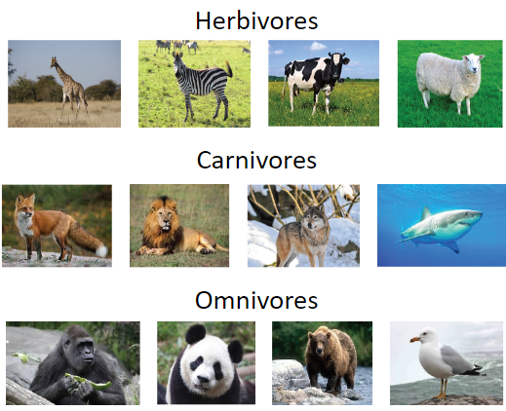  Remember - In year 1, you identified and named a variety of common animals that were carnivores, herbivores and omnivores.  Animals who just eat plants are called herbivores. Animals that just eat other animals are called carnivores. Animals that eat plants AND animals are called omnivores. | Key Question - Are you a herbivore, carnivore or omnivore? Explain why you think this.
Word Bank
herbivore, carnivore, omnivore, plant, animal, producer, consumer, diet, nutrition, eat, predator, prey
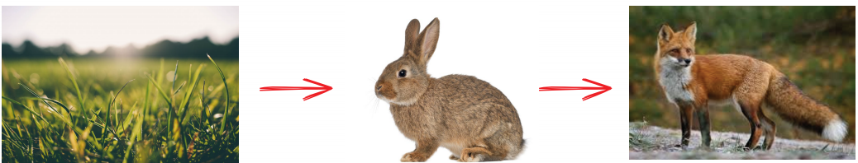
Food chains - Sometimes, scientists use food chains to show what different animals eat in a habitat. This is a simple food chain:In a food chain, the arrow means ‘is eaten by’. Grass is eaten by the rabbit The rabbit is eaten by the fox.
Watch this video to learn about different food chains. https://www.bbc.co.uk/bitesize/topics/zx882hv/articles/z3c2xnb Explore differernt food chains you might find in a woodland habitat using this game. https://www.bbc.co.uk/bitesize/topics/zbnnb9q/articles/zsphrwx
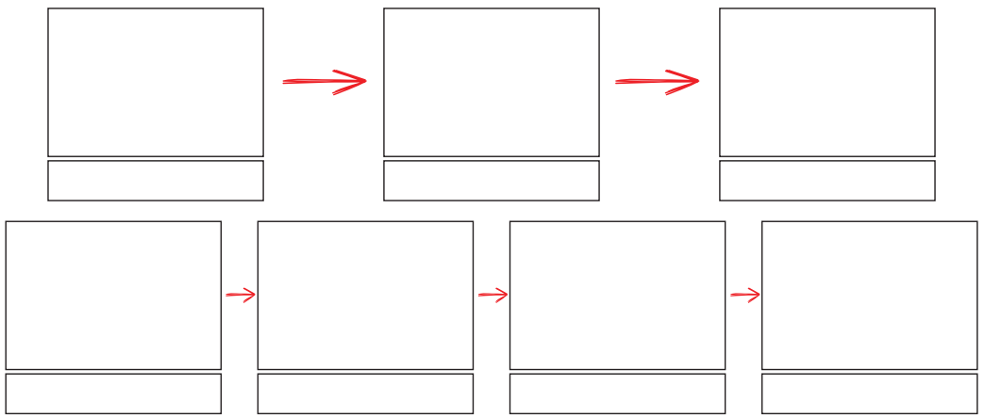
Draw your favourite food chains in the boxes below. Draw a picture of the living thing and then label it.
What I know now that I didn’t know before.

