EARLY BIRD MATHS 1

MUST:
12 + 4 + 4 =
43 x 0 =
109 – 10 =
6 x 4 =
80 ÷ 1 =
499 + 50 =
354 + 256 =
3/7 + 3/7 =
72 ÷ 8 =
4916 + 358 =
945 – 178 =
2.9 + 5.3 =

SHOULD:
43 x 5 =
2 x 5 x 3 =
36.05 x 10 =
10,348 – 458 =
20 x 40 =
467.1 ÷ 1000 =
2³ + 2² =
Remember:
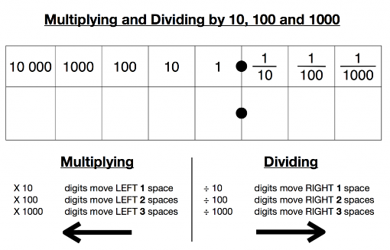

COULD:
2/5 of 30
5316 ÷ 6 =
1/3 of 507 =
28 x 53 =
31.8 x 4 =
26.8 – 6.12 =

CHALLENGE:
0.03 = ?% (What does percent mean?)
1 1/2 x 2 = (turn the fraction into a decimal)
0.2 = ?/10 (look at the place value columns)
5/6 - 2/3 = (denominators have to be the same)

EARLY BIRD MATHS 2

MUST:
16 + 8 + 8 =
703 + 100 =
87 x 1 =
893 + 27 =
305 x 0 =
491 – 8 =
6 x 8 =
36 ÷ 3 =
2639 + 1447 =
234 – 91 =

SHOULD:
8² =
5 x 4 x 2 =
75 x 6 =
6.1 x 10 =
34,555 – 15,671 =
50 x 30 =
2.06 ÷ 100
Remember:

COULD:
1/5 of 75 =
576 ÷ 4 =
42 x 39 =
7.3 + 1.48 =
3/7 of 700 =
2.67 x 5 =

CHALLENGE:
0.4 = ?% (What does percent mean?)
1 3/4 x 5 = (turn the fraction into a decimal)
0.8 = ?/100 (look at the place value columns)
4/5 + 1/10 = (denominators have to be the same)

EARLY BIRD MATHS 3

MUST:
32 + 4 + 4 =
888 – 10 =
21 x 0 =
245 + 7 =
2 x 8 =
245 ÷ 1 =
871 + 109 =
49 ÷ 7 =
2/9 + 5/9 =
873 – 97 =
1.9 + 3.6 =

SHOULD:
59,145 + 2878 =
3 x 5 x 3 =
143 x 7 =
45,902 – 15,005 =
9.3 ÷ 10 =
7.2 x 100 =
30 x 60 =
3³ + 3² =
Remember:

COULD:
4/7 of 14 =
5217 ÷ 3 =
¼ of 508 =
43.8 x 6 =
306 x 24 =
52.4 – 6.67 =

CHALLENGE:
0.65 = ?% (What does percent mean?)
3 1/4 x 3 = (turn the fraction into a decimal)
0.3 = ?/10 (look at the place value columns)
3/4 - 1/8 = (denominators have to be the same)

EARLY BIRD MATHS 4

MUST:
18 + 6 + 6 =
2360 + 100 =
25 x 1 =
36 ÷ 4 =
547 + 38 =
435 x 0 =
499 + 5 =
6/7 – 2/7 =
6 x 7 =
504 – 85 =

SHOULD:
36,839 + 31,878 =
9 x 4 x 2 =
9 ² =
762 ÷ 6 =
17.4 – 5.1 =
33,321 – 23,406 =
80.03 ÷ 10 =
3104 x 8 =
28.8 x 1000 =
30 x 200 =
Remember:

COULD:
1/8 of 72 =
2.126 x 7 =
47 x 81 =
5/7 of 105 =
6.1 + 2.35 =

CHALLENGE:
0.9 = ?% (What does percent mean?)
2 3/4 x 2 = (turn the fraction into a decimal)
0.1 = ?/100 (look at the place value columns)
5/6 + 1/12 = (denominators have to be the same)

